Catherine E. Pugh Room 250
Mayor City Hall
Baltimore, MD 21202

PRIVILEGED AND CONFIDENTIAL
M E M O R A N D U M: March 22nd, 2017

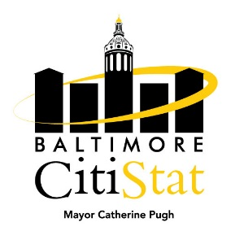
TO: The Honorable Mayor Catherine E. Pugh
Peter Hammen, Chief Operating Officer
Tisha Edwards, Chief of Staff
Jim Smith, Chief of Strategic Alliances
Sameer Sidh, Director of CitiStat

FROM: CitiStat Team

SUBJECT: Operational Liabilities Stat Meeting Summary Briefing

Making Progress

- Workers’ Compensation Claims. The Office of Risk Management sends out a monthly template summarizing workers’ compensation claims and costs by agency. Below is a table summarizing the most recent data for Fiscal Year 2017. The number of claims in February 2017 either equaled or were below average for all reporting agencies except for one.

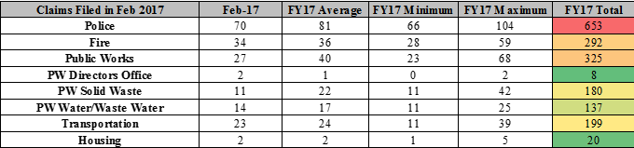

Needs Improvement

- Vacancies. The Bureau of Budget Management and Research provided to CitiStat an agency breakdown of vacancies as of March 1st, 2017. The tables below detail the number of vacancies (by service) as of March 1st, 2017 and the ‘Total Cost,’ which equals the total amount of salary plus ‘Other Personnel Costs.’ The Police Department, Department of Public Works, and Housing all continue to carry a high number of vacancies. The panel discussed ongoing recruiting efforts at each agency and how they can be improved.

